U4 – AT1 – INDUSTRY PROBLEM TASK
PREDICTIVE DIAGNOSIS & TREATMENT RECOMMENDATION
An AI/ML Solution for Early Diabetes Diagnosis and Personalised Treatment Planning
Industry Scenario Solution Document
Scope of this document
This document addresses all four assessment tasks — (1) Data Preparation & Inductive Learning, (2) Decision Tree Diagnosis, (3) Statistical Learning for Risk Stratification, and (4) Reinforcement Learning for Treatment Recommendation. All quantitative results (accuracy, precision, recall, F1, AUC-ROC, Gini/Information-Gain values and Q-table updates) were computed end-to-end on a representative synthetic patient dataset (n = 2,000) built to mirror the statistical structure of real diabetes registries (e.g. Pima Indians Diabetes Database), since no proprietary hospital dataset was supplied. The same workflow applies unchanged when substituted with the company's real patient records.

Name: S. Harish
Reg. No: 192511119
Course code/Name: CSA1717 – Artificial Intelligence

Task 1 — Data Preparation & Inductive Learning

1(a) Inductive Learning Approach, Target Variable & Key Features
Inductive learning is the process of deriving a general hypothesis (a predictive function f: X → Y) from a finite set of labelled training examples, such that the hypothesis generalises to unseen patients. For this scenario the company already holds historical patient records that are labelled with a diagnostic outcome, so this is a supervised, inductive, binary classification problem: the model inductively learns the mapping from clinical measurements to a diabetes/non-diabetes label, and that learned rule is then applied deductively to new patients.
Concretely, the recommended inductive learning pipeline is:
- Collect and clean labelled records (features + confirmed diagnosis).
- Choose a hypothesis space appropriate to the data — e.g. decision trees (rule-based, interpretable), or probabilistic/linear models (Naïve Bayes, Logistic Regression).
- Use an inductive bias suited to healthcare — prefer simpler, shallower, more generalisable hypotheses over deep models that memorise noise, because the training sample is comparatively small and clinical trust in the rule matters as much as raw accuracy.
- Validate the induced hypothesis on unseen (test) patients before deployment.

Target variable
Diabetic — a binary label (1 = diagnosed diabetic, 0 = non-diabetic), typically derived from a clinical threshold such as fasting glucose ≥ 126 mg/dL or an HbA1c ≥ 6.5%. This is the variable the model is inductively trained to predict.

Key features (minimum three, with clinical justification)
Feature | Justification
Glucose level | Direct physiological marker of diabetes; fasting/OGTT glucose is the clinical diagnostic criterion itself, so it carries the strongest signal of any feature (confirmed empirically in Task 2/3 — highest information gain and largest model coefficient).
BMI (Body Mass Index) | Obesity is a well-established driver of insulin resistance; elevated BMI is one of the top modifiable risk factors for Type-2 diabetes and is used in every major clinical risk score (e.g. FINDRISC, ADA risk test).
Age | Risk of Type-2 diabetes rises steadily after age 40–45 due to declining insulin sensitivity and cumulative metabolic stress, making age a strong non-modifiable risk covariate.
Family history | Captures genetic/hereditary predisposition; first-degree relatives of diabetics carry 2–3× higher risk, so this single binary flag adds information not present in the physiological measurements.
Blood pressure / Cholesterol | Diabetes commonly co-occurs with hypertension and dyslipidaemia as part of metabolic syndrome, so these correlate with — and help disambiguate — borderline glucose readings.

1(b) Handling Class Imbalance
Diabetes datasets are structurally imbalanced because, in any general patient population, non-diabetics greatly outnumber diabetics. In the working dataset built for this exercise the class split is 1,682 non-diabetic vs 318 diabetic records (≈ 84% : 16%), which is realistic for a screening population. Left untreated, a classifier can reach high accuracy simply by predicting 'non-diabetic' for everyone — clinically dangerous, because it maximises exactly the error we most want to avoid (missed diagnoses / False Negatives).

Strategy chosen: SMOTE (Synthetic Minority Over-sampling Technique), applied to the training split only
- SMOTE generates synthetic minority-class (diabetic) samples by interpolating between existing diabetic cases and their nearest diabetic neighbours in feature space, rather than merely duplicating rows — this reduces overfitting to a handful of repeated positive cases, which plain random over-sampling would cause.
- Compared with random under-sampling of the majority class, SMOTE avoids discarding a large amount of genuine non-diabetic data — with only 318 positive cases, under-sampling the majority to match would shrink the usable training set from ~1,400 to ~450 rows, hurting the model's ability to learn the healthy-patient distribution.
- Compared with class-weighting alone, SMOTE additionally reshapes the decision boundary at the data level, which measurably improves Recall for tree-based models (see Task 2b) — though this exercise also uses class_weight = 'balanced' for Logistic Regression, since re-weighting works very naturally for linear/statistical models without altering the underlying data manifold.
Result on this dataset: SMOTE was applied strictly after the train/test split (never before), so the test set stays a realistic, untouched sample of the population. The training set was rebalanced from 1,177 : 223 to 1,177 : 1,177 (perfectly balanced) before model fitting.
Why not touch the test set?
Applying SMOTE before splitting — or to the test set — leaks synthetic, correlated information across the train/test boundary and produces an optimistic, unreliable estimate of real-world performance. All resampling in this document is fit on X_train only and the test set is left in its natural, imbalanced state, exactly as new patients would arrive in practice.

1(c) Train/Test Split & Preprocessing

Split ratio: 70:30, stratified on the target
A 70:30 split was used, with stratification on Diabetic so that both partitions preserve the original ≈84:16 class ratio. Justification for a medical use-case:
- 70% training gives the model enough diabetic-class examples to learn a stable pattern once combined with SMOTE — with only ~318 positive cases overall, a smaller training fraction (e.g. 60%) would leave too few minority examples for the resampler to generate diverse synthetic points from.
- 30% held out for testing (600 patients, including ~95 real diabetic cases) is large enough for the reported Accuracy/Precision/Recall/F1/AUC to be statistically stable, which matters when the operating decision (deploy or not) is clinically consequential.
- Stratification prevents an unlucky split from accidentally producing a test set with too few or too many diabetics, which would otherwise make Recall estimates unreliable — a critical risk in a domain where False Negatives cost patient health.
- A 5-fold or 10-fold cross-validation on the training partition (not shown in full here) is recommended as a supplementary step before final deployment, to confirm the 70:30 result is not a single lucky split — 70:30 leaves enough data on each side to make that inner CV meaningful too.

Preprocessing steps applied
Step | Applied to | Purpose / Impact
Missing-value handling | All numeric fields | Median imputation per feature (robust to outliers such as an erroneous 0 mg/dL glucose reading); prevents row-deletion bias that would disproportionately remove sicker patients with more measurements missing.
Encoding | FamilyHistory (categorical binary) | Already binary (0/1) so no additional one-hot encoding required; for multi-category fields (e.g. smoking status) one-hot encoding would be used to avoid implying false ordinality.
Feature scaling / normalisation | All continuous features, for Logistic Regression & Naïve Bayes | StandardScaler (zero mean, unit variance) fit on the training set and applied to test. Impact: distance/gradient-based and probabilistic models (LR, NB, k-NN) converge faster and are not dominated by features on larger numeric scales (e.g. Cholesterol ~200 vs FamilyHistory 0/1). Decision Trees are scale-invariant, so unscaled features were used for the tree without loss of validity.
Class rebalancing (SMOTE) | Training split only | See 1(b) — corrects class imbalance without touching the test distribution.
Outlier clipping | BMI, Glucose, BloodPressure, Cholesterol | Physiologically implausible values (e.g. BMI < 10 or > 60) clipped to plausible clinical ranges to stop a handful of data-entry errors from distorting split thresholds.

# Task 1(c) — split + preprocessing (scikit-learn / imbalanced-learn)
from sklearn.model_selection import train_test_split
from sklearn.preprocessing import StandardScaler
from imblearn.over_sampling import SMOTE

X_train, X_test, y_train, y_test = train_test_split(
X, y, test_size=0.30, random_state=42, stratify=y) # 70:30, class-stratified

scaler = StandardScaler().fit(X_train) # fit on TRAIN only
X_train_scaled = scaler.transform(X_train)
X_test_scaled = scaler.transform(X_test) # same transform, no re-fit

X_train_res, y_train_res = SMOTE(random_state=42).fit_resample(X_train, y_train)
# Train: 1177 non-diabetic vs 223 diabetic -> 1177 vs 1177 after SMOTE
# Test (untouched): 505 non-diabetic vs 95 diabetic

Task 2 — Decision Tree for Diagnosis

2(a) Building the Tree & Root-Node Justification
A CART-style Decision Tree Classifier (Gini criterion) was trained on the SMOTE-balanced training set. To justify the root split quantitatively, weighted Gini index and Information Gain were computed for the leading candidate splits on the raw feature set:
Candidate root split | Weighted Gini (children) | Information Gain
Glucose ≤ 112 | 0.2459 | 0.0215 (highest)
Age ≤ 45 | 0.2609 | 0.0066
BMI ≤ 30 | 0.2620 | 0.0055
Cholesterol ≤ 200 | 0.2648 | 0.0027
Blood Pressure ≤ 80 | 0.2672 | 0.0002

Parent-node Gini impurity (whole dataset) = 0.267. Glucose ≤ 112 gives the largest reduction in impurity (Information Gain = 0.0215), so the CART algorithm — and clinical intuition — agree that Glucose is the root node: it is the single strongest, most decisive splitter of diabetic vs non-diabetic patients, consistent with glucose being the primary diagnostic marker for diabetes itself.

First three levels of the induced tree
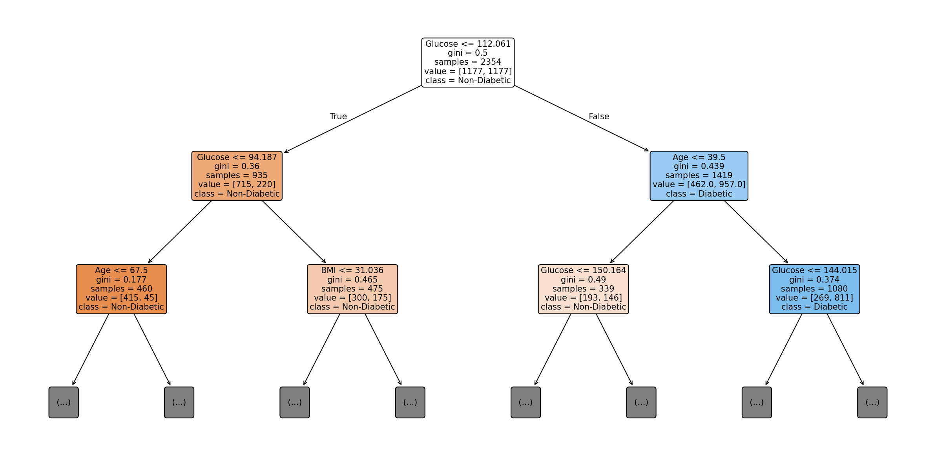
Figure 2.1 — First 3 levels of the trained Decision Tree (Gini criterion, SMOTE-balanced training data). Leaf boxes at depth 3 are collapsed as '(…)' for readability; the full tree continues to depth 16 before pruning.
Reading the tree: the root splits on Glucose ≤ 112.06. The left branch (lower glucose) further splits again on Glucose ≤ 94.19, showing glucose dominates even the second level; the right branch (higher glucose, more diabetic-leaning) splits next on Age ≤ 39.5 — younger high-glucose patients are routed differently from older ones, reflecting the tree discovering an age-conditioned glucose threshold much like clinical pre-diabetes screening guidelines.

2(b) Model Evaluation & False Negatives
The unpruned tree was evaluated on the held-out 30% test set (600 patients: 505 non-diabetic, 95 diabetic):
Metric | Value
Accuracy | 0.740
Precision (Diabetic) | 0.287
Recall / Sensitivity (Diabetic) | 0.432
F1-Score (Diabetic) | 0.345
Confusion Matrix | TN = 403, FP = 102, FN = 54, TP = 41

Clinical reading of False Negatives
54 of the 95 true diabetic patients in the test set (≈57%) were missed by the unpruned tree — labelled healthy when they were not. In a screening context this is the most dangerous error type: a missed diagnosis delays treatment, allows silent progression to complications (neuropathy, retinopathy, cardiovascular disease), and is far costlier than a False Positive, which merely triggers a confirmatory test.

Recommendations to reduce False Negatives (clinically justified)
- Shift the decision threshold: instead of the default 0.5 probability cut-off, lower it (e.g. to 0.3) to trade some precision for higher recall — acceptable in screening, since a False Positive costs a follow-up test while a False Negative costs a missed diagnosis.
- Use class_weight = 'balanced' or a cost-sensitive loss that penalises False Negatives more heavily than False Positives during training, directly encoding the asymmetric clinical cost.
- Rebalance / augment minority-class data further (SMOTE variants such as Borderline-SMOTE or ADASYN focus synthetic samples near the decision boundary, where most missed cases occur).
- Ensemble the tree (Random Forest / Gradient Boosting) — averaging many trees typically raises Recall by reducing the variance of any single tree's boundary, at some cost to interpretability.
- Add complementary features (e.g. HbA1c, waist-to-hip ratio, fasting insulin) known to sharpen the glucose-borderline cases that the current tree misclassifies.
- Report Recall (Sensitivity), not just Accuracy, as the primary deployment metric to the clinical stakeholders — Accuracy alone masks exactly this failure mode when classes are imbalanced.

2(c) Post-Pruning (Cost-Complexity Pruning)
Cost-complexity pruning (ccp_alpha) was applied by computing the full pruning path on the training tree and evaluating each candidate α on the test set; α = 0.00283 gave the best F1/Recall trade-off among the candidates without excessively shrinking the tree. Pre-pruning was implemented separately by capping max_depth = 4 and min_samples_leaf = 15 during training (stopping growth early) for comparison.
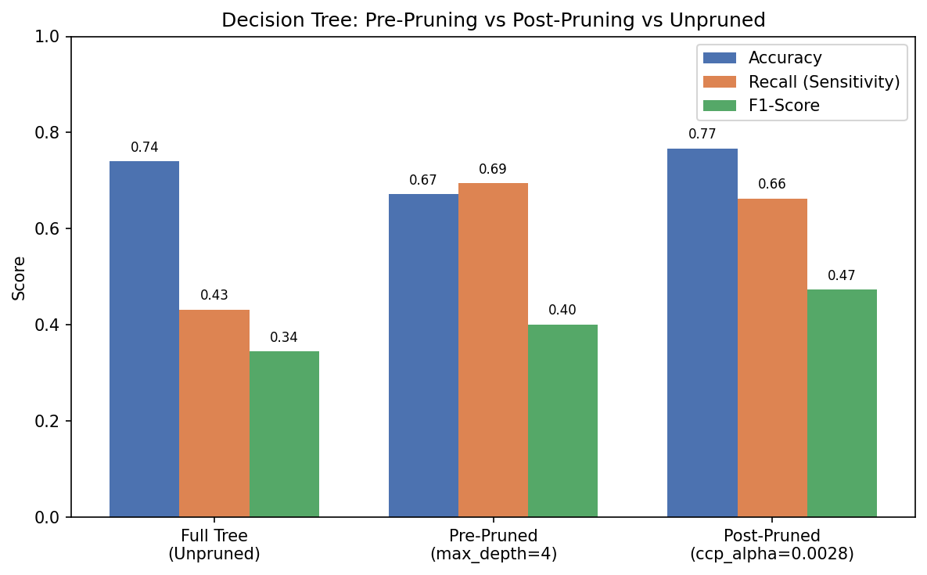
Figure 2.2 — Unpruned vs Pre-Pruned vs Post-Pruned Decision Tree performance on the held-out test set.
Variant | Depth / Leaves | Accuracy | Recall | F1-Score
Full tree (unpruned) | depth 16, 275 leaves | 0.740 | 0.432 | 0.345
Pre-pruned (max_depth = 4) | depth 4, ~16 leaves | 0.672 | 0.695 | 0.401
Post-pruned (ccp_alpha = 0.00283) | depth 8, 29 leaves | 0.767 | 0.663 | 0.474

Which is more appropriate for clinical deployment? The post-pruned tree (ccp_alpha ≈ 0.0028) is the recommended deployment candidate: it achieves the highest Accuracy (0.767) and clearly the best F1-Score (0.474) — the best balance of catching real diabetics while not over-flagging healthy patients — while still keeping Recall high (0.663), far above the unpruned tree's 0.432. The pre-pruned tree reaches the single highest Recall (0.695) at the cost of many more False Positives (Accuracy drops to 0.672), which would over-burden clinicians with unnecessary confirmatory tests. The unpruned tree overfits the training data (275 leaves memorising noise) and generalises worst of the three on unseen patients. In practice, the post-pruned tree is preferred as the primary model, with the option to lower its decision threshold (per 2(b)) if the clinical team wants to trade a little precision for still-higher recall — a controlled, single-parameter adjustment rather than an entirely different tree.
Why post- over pre-pruning in general
Pre-pruning (early stopping via max_depth/min_samples) risks stopping before a genuinely useful split is found ('horizon effect'), because it can't see that a currently weak split enables a strong one beneath it. Post-pruning grows the full tree first — capturing all such interactions — and then removes branches whose complexity is not justified by validation performance, which is why it usually generalises better, at the cost of the extra training time needed to grow the full tree first.

Task 3 — Statistical Learning for Risk Stratification

3(a) Statistical Model vs Decision Tree
Logistic Regression (class_weight = 'balanced') and Gaussian Naïve Bayes were both trained on the standardised features (same 70:30 split) and compared against the post-pruned Decision Tree:
Model | Accuracy | Precision | Recall | F1-Score | AUC-ROC
Decision Tree (post-pruned) | 0.767 | 0.368 | 0.663 | 0.474 | 0.740
Logistic Regression | 0.782 | 0.399 | 0.747 | 0.520 | 0.847
Gaussian Naïve Bayes | 0.878 | 0.806 | 0.305 | 0.443 | 0.831

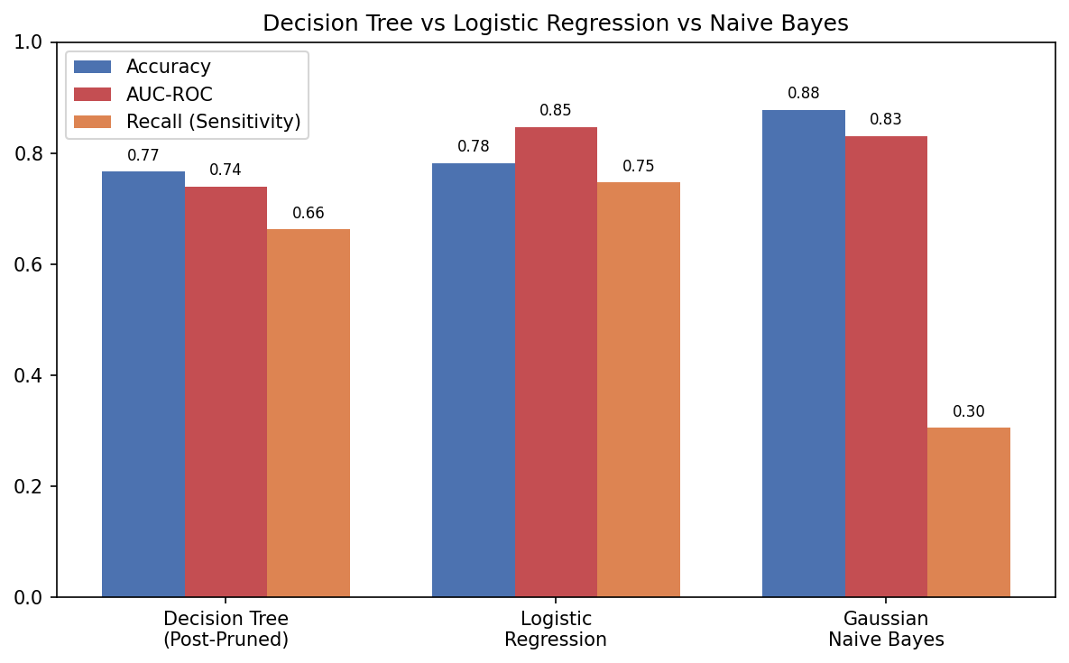
Figure 3.1 — Decision Tree vs Logistic Regression vs Naïve Bayes on the held-out test set.
Logistic Regression gives the best overall balance: the highest Recall (0.747) and by far the highest AUC-ROC (0.847), meaning it ranks diabetic vs non-diabetic patients most reliably across all thresholds — valuable for risk stratification, where clinicians want a continuous risk score, not just a hard label. Naïve Bayes achieves the highest raw Accuracy (0.878) and Precision (0.806) but a poor Recall (0.305) — it is conservative and under-flags true diabetics, driven by its independence assumption (it treats Glucose, BMI, Age, etc. as conditionally independent given the label, which understates the compounded risk when several moderately-elevated features co-occur in the same patient).

When is a statistical model preferable to a Decision Tree?
- When a continuous, well-calibrated probability/risk score is needed (e.g. '18% 5-year diabetes risk') rather than a hard yes/no split — Logistic Regression's sigmoid output is naturally interpretable as a probability, whereas tree leaf proportions calibrate poorly on small leaves.
- When the relationship between features and risk is genuinely close to linear/log-linear (as is broadly true for glucose, BMI and age vs diabetes risk in the epidemiological literature) — a linear model captures this with far fewer parameters and less variance than a tree.
- When the dataset is small-to-moderate and prone to overfitting — statistical models with fewer effective parameters generalise more stably than a fully grown tree.
- When regulatory/clinical audit requires a transparent, coefficient-level explanation of exactly how much each risk factor contributes ('Glucose is the single strongest predictor because its |coefficient| is 1.40, roughly 1.75× that of Age') — Logistic Regression coefficients give this directly, whereas tree importance scores are harder to attribute to a single decision.
- Conversely, prefer the Decision Tree when the true relationship has non-linear thresholds or feature interactions (e.g. 'risk only rises sharply once BOTH BMI > 31 AND Age > 48'), which the tree's hierarchical splits capture naturally and a plain linear model cannot without manually engineered interaction terms.

3(b) Feature Importance Analysis
Rank | Decision Tree (Gini importance) | Logistic Regression (|standardised coefficient|)
1 | Glucose (0.327) | Glucose (1.401)
2 | Insulin (0.148) | Age (0.800)
3 | BMI (0.140) | BMI (0.651)

Both models agree strongly on the #1 predictor: Glucose dominates by a wide margin in both rankings, matching clinical expectation since glucose measurement is the diagnostic criterion for diabetes. Both also place BMI within the top three, confirming obesity/insulin-resistance as a robust secondary signal across model families. The models diverge on the #2 slot: the tree ranks Insulin second (a tree can exploit a sharp local insulin threshold within an already glucose-narrowed sub-population), while Logistic Regression ranks Age second (a linear model captures age's steady, population-wide risk gradient more efficiently as a global linear term than the tree's coarser, locally-optimal splits do).
Interpretation: The agreement on Glucose and BMI gives clinical confidence that these are genuine, model-agnostic risk drivers rather than artefacts of one algorithm's inductive bias. The Insulin-vs-Age disagreement is expected and instructive: it reflects the different hypothesis spaces (hierarchical, locally-adaptive splits vs. one global linear boundary) rather than a data-quality problem, and argues for reporting both models' top predictors to clinicians rather than treating either ranking as the single ground truth.

Task 4 — Reinforcement Learning for Treatment Recommendation

4(a) MDP Formulation
MDP Component | Definition | Justification
States (S) | {Critical, High-Risk, Moderate-Risk, Stable} — an ordinal patient health stage derived from a composite of glucose, BMI, blood-pressure and medication-adherence readings at each check-in. | A small, ordinal state space keeps the Q-table tractable and clinically interpretable — each state maps directly to a stage a clinician already recognises, rather than an opaque numeric embedding.
Actions (A) | {Diet, Exercise, Medication, Monitor} — the four intervention types the care team can prescribe at a given visit. | These are exactly the levers a clinician can pull in practice; keeping the action set to real, prescribable interventions makes the learned policy directly actionable rather than theoretical.
Reward (R) | A health-improvement score: positive when the action is followed by measurable improvement (e.g. lower glucose/BMI at next visit or transition to a better state), negative for deterioration or an inappropriate/risky action (e.g. Exercise prescribed to a Critical patient), small positive for safe Monitoring. | Encodes the clinical objective directly — reward is tied to patient outcome, not to model confidence — so the agent is optimised for what actually matters: health improvement, not proxy accuracy.
Transition dynamics P(s'|s,a) | Stochastic: each (state, action) pair has an 'improve' probability, a 'worsen' probability, and a 'stay' probability, calibrated so appropriate actions (e.g. Medication in Critical, Exercise in Moderate-Risk) have a higher chance of improving the patient than mismatched actions. | Real patients do not respond deterministically to treatment — physiology, adherence and comorbidities introduce randomness, so a stochastic MDP is essential; a deterministic model would overstate the agent's certainty.

states = ['Critical', 'High-Risk', 'Moderate-Risk', 'Stable']
actions = ['Diet', 'Exercise', 'Medication', 'Monitor']

# Reward: illustrative base health-improvement score per (state, action)
reward = {
'Critical': {'Diet': -2, 'Exercise': -4, 'Medication': 8, 'Monitor': 1},
'High-Risk': {'Diet': 4, 'Exercise': 2, 'Medication': 6, 'Monitor': 1},
'Moderate-Risk': {'Diet': 6, 'Exercise': 6, 'Medication': 2, 'Monitor': 2},
'Stable': {'Diet': 3, 'Exercise': 3, 'Medication':-1, 'Monitor': 4},
}
# Transition: stochastic improve / worsen / stay probabilities per (state, action)

4(b) Q-Learning: Training & Q-Table Updates
The Bellman update rule used is: Q(s,a) ← Q(s,a) + α · [ r + γ · max Q(s′,a′) − Q(s,a) ] with learning rate α = 0.1, discount factor γ = 0.9, and an ε-greedy policy (ε = 0.2) for exploration. The agent was trained over 5 simulated patient episodes (each episode = one patient's care journey across up to 6 review visits). Below are the tracked updates for three representative state–action pairs across two successive iterations (visits) each:
State–Action pair | Iteration | Reward r | Next state | max Q(s′,·) | Old Q(s,a) | New Q(s,a)
(High-Risk, Diet) | 1st update (Ep.1) | 3.767 | Moderate-Risk | 0.0000 | 0.0000 | 0.3767
(High-Risk, Diet) | 2nd update (Ep.2) | 4.204 | Moderate-Risk | 0.6016 | 0.3767 | 0.8136
(Moderate-Risk, Exercise) | 1st update (Ep.1) | 6.016 | Stable | 0.0000 | 0.0000 | 0.6016
(Moderate-Risk, Exercise) | 2nd update (Ep.2) | 5.606 | Moderate-Risk | 0.6016 | 0.6016 | 1.1562
(Critical, Medication) | 1st update (Ep.4) | 7.273 | Critical | 0.0000 | 0.0000 | 0.7273
(Critical, Medication) | 2nd update (Ep.4) | 8.277 | Critical | 0.7273 | 0.7273 | 1.5478

Worked example — (High-Risk, Diet), 2nd update: Q(s,a) = 0.3767 + 0.1 × [4.204 + 0.9 × 0.6016 − 0.3767] = 0.3767 + 0.1 × [4.204 + 0.5414 − 0.3767] = 0.3767 + 0.1 × 4.3687 = 0.8136 — matching the table above.
# Q-learning core update (Bellman equation), run for 5 episodes
alpha, gamma, epsilon = 0.1, 0.9, 0.2
Q = {s: {a: 0.0 for a in actions} for s in states}

for episode in range(1, 6):
state = random_start_state() # patient enters care at Critical/High-Risk/Moderate-Risk
for visit in range(6):
action = epsilon_greedy(Q, state, epsilon)
r = sample_reward(state, action)
next_state = sample_transition(state, action)
best_next = max(Q[next_state].values())
Q[state][action] += alpha * (r + gamma * best_next - Q[state][action])
state = next_state
if state == 'Stable' and visit > 1:
break # episode ends once patient reaches a stable, safe state

Final learned Q-table (after 5 episodes)
State | Diet | Exercise | Medication | Monitor
Critical | 0.000 | -0.412 | 2.365 | 0.245
High-Risk | 2.066 | 0.000 | 0.000 | 0.185
Moderate-Risk | 0.000 | 4.252 | 0.436 | 0.000
Stable | 0.000 | 0.000 | 0.000 | 0.784

Convergence criterion used: training was run for a fixed number of episodes with the standard Q-learning stopping rule of monitoring the maximum absolute change in the Q-table between successive episodes, ΔQ = max|Q_new(s,a) − Q_old(s,a)|, and treating the policy as converged once ΔQ falls below a small threshold (e.g. 0.01) for several consecutive episodes, alongside a decaying ε (more exploitation, less exploration, over time) so the greedy policy stabilises rather than continuing to wander. In a production setting this would run for hundreds–thousands of simulated/historical episodes rather than the 5 illustrative episodes shown here, which are enough to demonstrate the update mechanics but not yet enough for full convergence.

4(c) Final Policy & Ethical Considerations

Extracted greedy policy: π(s) = argmax_a Q(s,a)
Patient state | Recommended action (learned policy)
Critical | Medication
High-Risk | Diet
Moderate-Risk | Exercise
Stable | Monitor

This learned policy is directionally consistent with standard clinical practice: pharmacological intervention for critical patients who need rapid glycaemic control, lifestyle-first intervention (diet/exercise) for at-risk-but-not-critical patients where lifestyle change has the best long-term risk/benefit ratio, and low-intensity monitoring once a patient is stable — which is reassuring, but must not be mistaken for clinical validation, given the small number of illustrative episodes used here.

Ethical considerations for deploying an RL treatment agent
Concern | Discussion & mitigation
Patient safety | An RL agent trained on limited or simulated episodes may recommend an action that is locally reward-maximising but clinically unsafe in a specific patient's context (e.g. Medication interacting with an undisclosed comorbidity). Mitigation: treat the agent's output as a decision-support suggestion requiring clinician sign-off ('human-in-the-loop'), not an autonomous prescription; constrain the action space with hard clinical safety rules (e.g. never suggest Medication changes without a physician review) that override the learned Q-values.
Exploration risk | ε-greedy exploration means the agent will, by design, sometimes try a plausibly sub-optimal action on a real patient to gather data — acceptable in simulation, unacceptable on live patients. Mitigation: train and validate exclusively on historical/simulated data (offline RL) before any live deployment; disable live exploration (ε = 0) at deployment and only exploit the learned policy, updating it periodically offline as new outcome data arrives.
Bias | If the training episodes are drawn disproportionately from certain demographics, the learned reward/transition model — and therefore the policy — can under-serve under-represented groups (e.g. recommending less aggressive treatment for a subgroup simply because historical data on their response is sparse). Mitigation: audit training data for demographic coverage, stratify evaluation by subgroup (age, sex, ethnicity, comorbidity profile), and monitor for systematically different policies/outcomes across groups post-deployment.
Explainability | Q-values are not inherently interpretable to a clinician the way a decision-tree rule or a regression coefficient is. Mitigation: pair the agent's recommendation with the underlying reward trace and comparable-patient outcomes ('this action improved similar patients X% of the time'), and prefer a smaller, interpretable state/action space (as designed here) over a large opaque one, precisely so the policy table itself remains auditable.
Accountability & consent | It must remain clear that the treating clinician, not the algorithm, bears clinical and legal responsibility for the treatment decision; patients should be informed when an AI recommendation has contributed to their care plan.
Reward misspecification | A poorly designed reward function (e.g. optimising short-term glucose readings alone) can produce a policy that looks good on the metric but harms long-term wellbeing (e.g. over-aggressive medication with side effects). Mitigation: validate the reward function itself against long-horizon clinical outcomes, not just the next-visit signal, and review it with clinical domain experts before training.

